
Call for Papers
2022 Online Symposium of the Network of Asian Environmental Philosophy
Dates: 17-18 June 2022 (Participation is free)
Theme: Diversity of Environmental Philosophies in Asia
Environmental philosophy explores the ways we, humans, relate to the environment. The environmental crisis urges us to (re-)explore how we relate and act towards the natural world. Approaches to environmental philosophy broadly conceived are highly diverse. This diversity is also reflected within traditions and grassroots perspectives on environmental issues in Asia. Therefore, there is a need to develop, exchange and make accessible these approaches to foster dialogue towards sustainable solutions.
The NAEP 2022 Online Symposium welcomes contributions from scholars, practitioners and stakeholders on a broad range of questions including but not limited to:
- Can we speak of “Asian Environmental Philosophy”?
- How is environmental philosophy conducted and practiced in different contexts and traditions in Asia?
- How environmental philosophies and the local ways of life influence each other?
- What could be the role of Asian environmental philosophies in a global context?
- What are the challenges and opportunities faced by environmental philosophy scholars in Asia?
- What is the role of Indigenous knowledge in Asia to address environmental issues?
We welcome abstract for individual presentations, panels and workshops proposals. Please submit your 200-250 words abstract by email to asiaenviphilo@gmail.com, including your name, affiliation and contact information, by February 21st 2022.
Language: The primary language of the conference is English. We aim to be non-native friendly, so we make it a rule that we speak slow and accessible English. If you would like to present in a language other than English, please contact us.
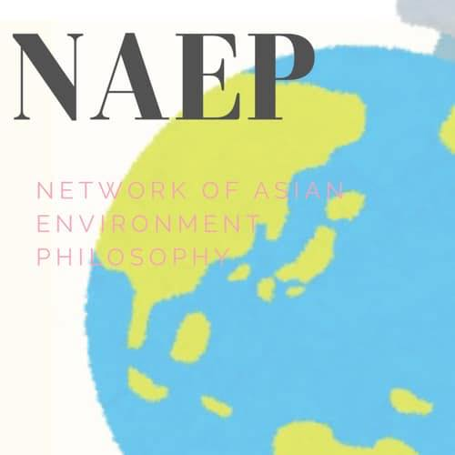
Organisation: Orika Komatsubara, Laÿna Droz, Romaric Jannel, Duy Hung Nguyen, Concordia Marie Lagasca-Hiloma, Jerry Imbong , Rika Fajrini
About the Network of Asian Environmental Philosophy (NAEP)
The Network of Asian Environmental Philosophy (NAEP) was founded by a group of scholars in the field of environmental philosophy in Asia in 2019 with the goal to support works related to environmental philosophy within Asian traditions of thoughts broadly conceived or related to grassroots perspectives on environmental issues in Asia. Visit our website: www.asiaenviphilo.com

